ORACLE DB - INTRODUCTION

GIOVAN BARREIRA

V 0.1
2025/03/15

Creative Commons Attribution - ShareAlike 4.0 International License
This work is licensed under a Creative Commons Attribution-ShareAlike 4.0 International License. You are free to:
- Share: Copy and redistribute the material in any medium or format.
- Adapt: Remix, transform, and build upon the material for any purpose, even commercially.
Under the following terms:
Attribution: You must give appropriate credit, provide a link to the license, and indicate if changes were made. You may do so in any reasonable manner, but not in any way that suggests the licensor endorses you or your use.
ShareAlike: If you remix, transform, or build upon the material, you must distribute your contributions under the same license as the original.
For more details, see Creative Commons.
https://creativecommons.org/licenses/by-sa/4.0/
Disclaimer
The information provided in this book is for educational purposes only. The author and publisher make no representations or warranties regarding the accuracy, completeness, or suitability of the content. The use of the information contained in this book is at the reader's own risk. The author and publisher shall not be held liable for any loss or damage, including but not limited to direct, indirect, incidental, or consequential loss or damage, arising from the use of the information provided.
Note: this e-book contain text generated by AI, please be careful.
Summary
OracleDB 6
Oracle DB inside a virtual machine 7
Essential OracleDB Tools and Technologies: Definitions and Roles 8
Installing process on Windows 9
Oracle Database Installing Process 10
JDK Installing Process 14
Instant Client and ProC Installing Process 16
Sqlcl Installing Process 16
Sql Developer Installing Process 17
Organizing the apps 17
Understanding Multitenant Architecture 18
CDB vs PDB vs Instance 20
Instance 20
Container 20
CDB (Container Database) 20
PDB (Pluggable Database) 20
Summary of Relationships 21
Initial accounts and databases in Oracle 21c XE 22
User types and privileges 23
Common Users 23
Local Users 23
System Privileges 23
Object Privileges 23
Roles 24
Administrative Privileges 24
PDB Lockdown Profiles 24
Basic commands 26
User creation 28
Local user (a PDB as scope) 28
Common user (a CDB as scope or more) 28
Object privileges 29
System privileges 30
Role creation 31
SQLPLUS VS SQL 33
Oracle manually PDB Creation & HR User Setup Guide (LINUX) 34
Oracle manually PDB Creation on Windows 37
DROP PDB MANUALLY 39
Oracle PDB Creation via DBCA 40
Oracle CDB creation 51
Exercises 52
Creating and managing tables 54
Understanding Tables in Oracle 54
Creating a Table 54
Inserting Data into the Table 54
Querying the Table 55
Modifying the Table Structure 55
Deleting Data 55
Dropping a Table 55
Hands-On Practice 55
Summary 55
References 57
Links for download 58
To Do 59

OracleDB
Oracle Database, often referred to as OracleDB or just Oracle, is a powerful relational database management system (RDBMS) developed by Oracle Corporation. It’s designed to store, manage, and retrieve large amounts of data efficiently, making it widely used in both enterprise and smaller-scale applications.
Here are some key features of OracleDB:
-Relational Structure: Data is stored in tables with rows and columns, making it easy to organize and query data.
-Pluggable Architecture: In the latest versions, Oracle supports a multitenant architecture with container databases (CDBs) and pluggable databases (PDBs), allowing efficient consolidation.
-Scalability: It’s built to handle anything from small applications to massive, enterprise-level workloads.
-Security: OracleDB offers robust security features such as encryption, user management, and data masking to protect sensitive information.
-Advanced Features: Includes tools for analytics, machine learning integration, in-memory processing, and support for both structured and unstructured data.
It's widely used in industries like finance, healthcare, retail, and more, providing businesses with reliable and scalable data solutions.

Oracle DB inside a virtual machine
To have an experience nearer to that of a production environment it is interesting configure the VM network as bridge and then configure a static IP in the router. With a scenario like that it is possible code in proC in WSL, for example, then connect ‘remotely’ to the Oracle VM.

Essential OracleDB Tools and Technologies: Definitions and Roles
JDK (Java Development Kit): A software development kit provided by Oracle for developing Java applications. It includes the Java compiler, Java Runtime Environment (JRE), and tools like javac for compiling code.
Instant Client SDK: A set of tools and libraries provided by Oracle that allows applications to connect to Oracle Database. It includes essential files for developing and deploying applications that use Oracle Call Interface (OCI), OCCI, and JDBC-OCI.
SQLcl (SQL Command Line): A modern command-line interface for interacting with Oracle Database. It’s like SQL*Plus but with additional features like scripting, JSON output, and easier usage for developers.
SQLPlus*: A basic command-line tool for executing SQL commands and PL/SQL blocks in Oracle Database. Often used by database administrators for simple queries and maintenance tasks.
SQL Developer: A GUI-based IDE (Integrated Development Environment) for Oracle Database, designed for developers and DBAs. It offers advanced features like query building, data modeling, debugging, and performance tuning.
OCI (Oracle Cloud Infrastructure): Oracle’s cloud computing platform, providing a range of services, including virtual machines, databases, storage, and networking, for cloud-based deployments and applications.
ProC*: A precompiler for embedding SQL statements in C or C++ programs. It allows developers to integrate SQL directly into their applications, combining database operations with C/C++ functionality.
DBCA (Database Configuration Assistant): A graphical tool for creating and managing Oracle databases. It simplifies tasks such as creating new databases, configuring database options, and setting up pluggable databases (PDBs) in multitenant architecture.

Installing process on Windows

Version 21
Oracle Database XE
https://www.oracle.com/database/technologies/xe-downloads.html
https://download.oracle.com/otn-pub/otn_software/db-express/OracleXE213_Win64.zip
Java JDK
Java Downloads | Oracle
https://download.oracle.com/java/21/latest/jdk-21_windows-x64_bin.exe
SQLcl (must be the version 21.3, the same one of the OracleXE213)
SQLcl Downloads 21.4.1
SQLcl Downloads 21.3
SQL Developer
Oracle SQL Developer Downloads
https://download.oracle.com/otn_software/java/sqldeveloper/sqldeveloper-24.3.1.347.1826-no-jre.zip
Oracle Instant Client
Oracle Instant Client Downloads
Instant Client for Microsoft Windows (x64) 64-bit
Instant Client for Linux x86-64 (64-bit)
ProC Precompiler
Precompiler Downloads

Oracle Database Installing Process

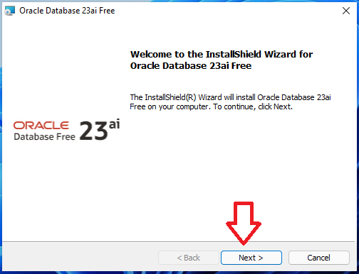
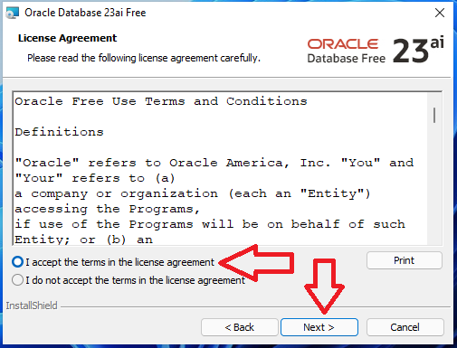

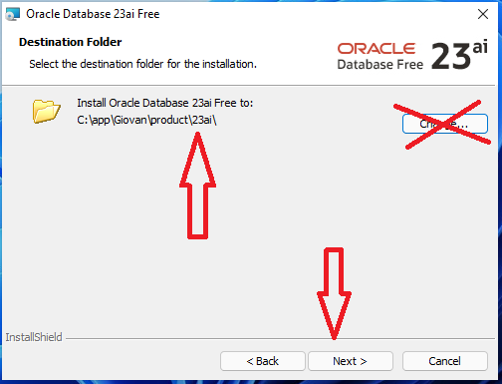
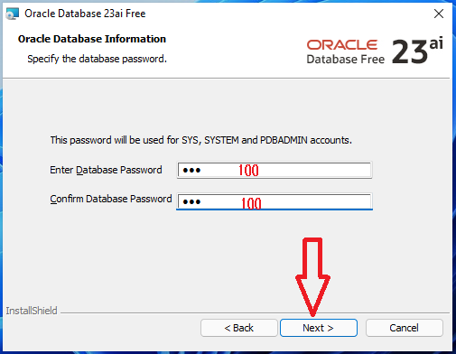

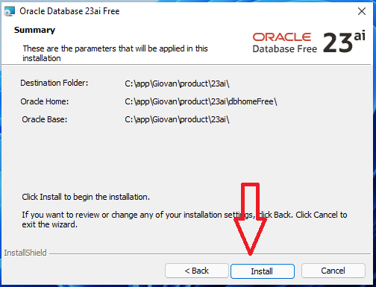
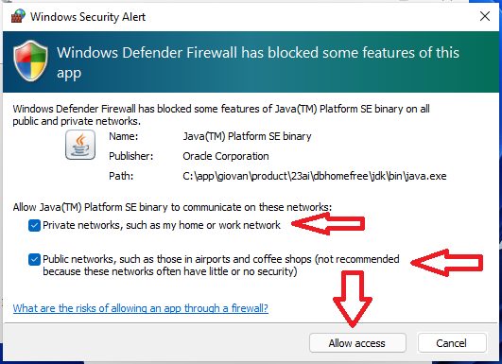

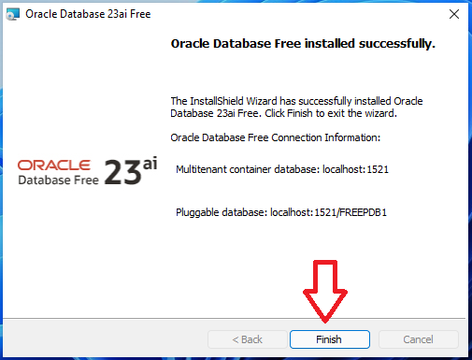
The install process also install SQLPlus, SQLcl and other tools. SQLcl has a small error produced by the install process, to correct that just download and extract sqlcl (21.3 not 21.4.1.17 like in the image) inside the Oracle XE 21 c path.
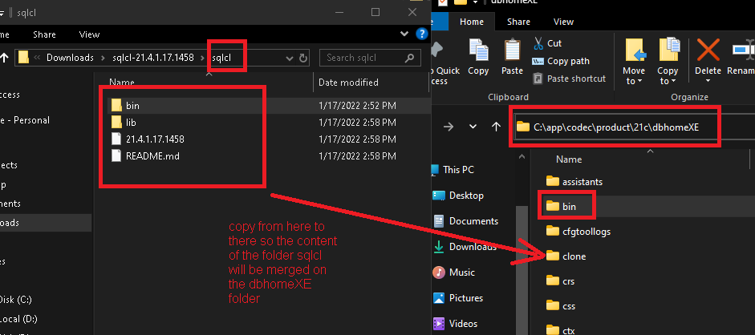
See the explanation on YouTube:
002 - 🚀 Oracle XE 21 + Java SDK + SQLcl Download, Install & Error Fix - Part 2

JDK Installing Process

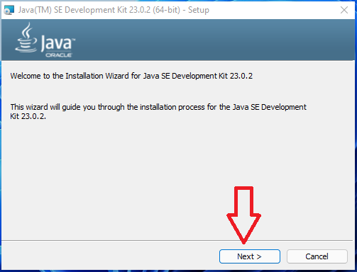

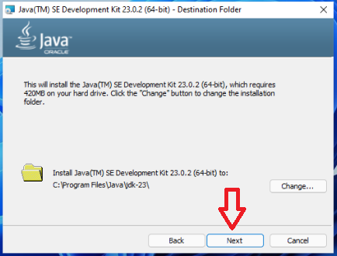

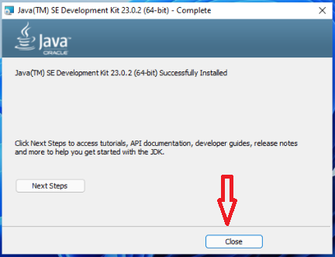

Instant Client and ProC Installing Process
We install those tools in another machine that we want to connect to the server. Just extract.

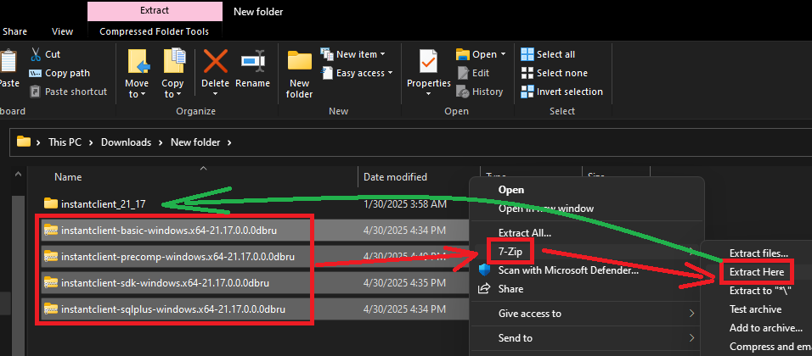

Sqlcl Installing Process
Just extract.
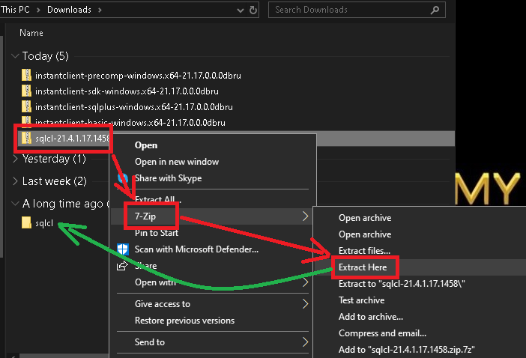

Sql Developer Installing Process
Just extract.

Organizing the apps
In order to keep all ‘portable’ apps organized we can keep all in the same directory.
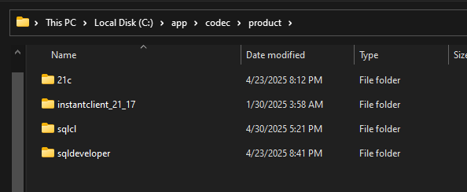

Understanding Multitenant Architecture
Oracle Database introduced Multitenant Architecture in Oracle 12c, which includes Container Databases (CDBs) and Pluggable Databases (PDBs). This architecture allows multiple databases (PDBs) to run inside a single Oracle instance, improving efficiency, manageability, and resource utilization.

🔹 1. What is a CDB (Container Database)?
A CDB (Container Database) is the main database that contains one or more Pluggable Databases (PDBs). It provides shared system resources such as memory, background processes, and system metadata for all PDBs inside it.
CDB Characteristics:
- A single Oracle instance manages multiple PDBs.
- Contains CDB$ROOT, which stores common system metadata and manages PDBs.
- Includes PDB$SEED, a template used to create new PDBs.
- Manages shared undo and redo logs.
- Has a common SYS and SYSTEM user across all PDBs.
CDB Components:
Component | Description
CDB$ROOT | Root container storing system metadata, common users, and system privileges.
PDB$SEED | A template PDB used to create new PDBs quickly.
PDBs | User-created pluggable databases (e.g., DB3PDB, DB2PDB).

🔹 2. What is a PDB (Pluggable Database)?
A PDB (Pluggable Database) is a self-contained, portable database stored inside a CDB. Each PDB contains its own user data, metadata, and schemas, but shares system resources with the CDB.
PDB Characteristics:
- Functions like a traditional database but shares the instance with other PDBs.
- Has its own tablespaces, users, and data dictionary.
- Can be plugged into or unplugged from a CDB.
- Runs independently, but administration is centralized at the CDB level.

🔹 3. Key Differences Between CDB and PDB
Feature | CDB (Container Database) | PDB (Pluggable Database)
Definition | A parent database that manages multiple PDBs | A self-contained database inside a CDB
System Metadata | Stored in CDB$ROOT | Stored in PDB itself
Users | Common users (C## prefix) exist across all PDBs | Local users specific to the PDB
Schemas | Common schemas for all PDBs | Own schemas separate from others
Backup & Restore | Backup affects all PDBs in the CDB | Can back up and restore individual PDBs
Performance Isolation | Shared memory, CPU, and background processes | Limited isolation; performance depends on CDB resources
Administration | Administered using CDB$ROOT | Can be administered separately but depends on CDB

🔹 4. Basic CDB and PDB Commands
Check Current Container:
SELECT SYS_CONTEXT('USERENV', 'CON_NAME') AS CURRENT_PDB FROM DUAL;

List Available PDBs in the CDB:
SHOW PDBS;
or
CopyEdit
SELECT PDB_ID, PDB_NAME, STATUS FROM DBA_PDBS;

Switch Between CDB and PDB:
ALTER SESSION SET CONTAINER=CDB$ROOT; -- Switch to root container
ALTER SESSION SET CONTAINER=DB3PDB; -- Switch to a specific PDB

Open a PDB:
ALTER PLUGGABLE DATABASE DB3PDB OPEN;

Close a PDB:
ALTER PLUGGABLE DATABASE DB3PDB CLOSE;

🔹 5. Advantages of Using CDB and PDB
✅ Efficient Resource Management – Multiple PDBs share memory and processes, reducing overhead.
✅ Easier Database Consolidation – Migrate existing databases into PDBs without needing separate instances.
✅ Simplified Backup & Recovery – You can back up the entire CDB or individual PDBs.
✅ Seamless Database Mobility – PDBs can be unplugged from one CDB and plugged into another.
✅ Improved Security & Isolation – Each PDB has separate schemas, tablespaces, and users.

🔹 Summary
1️⃣ CDB is the "container" that manages multiple PDBs and provides shared system resources.
2️⃣ PDBs are independent databases inside a CDB, each with its own users and data.
3️⃣ Switching between PDBs is easy using ALTER SESSION SET CONTAINER=PDB_NAME.
4️⃣ The architecture simplifies administration, reduces resource consumption, and enhances database consolidation.

CDB vs PDB vs Instance

Instance
Definition: An Oracle instance is the combination of Oracle's memory structures and background processes that operate a database.
Key Components:
-Memory Structures: Include the System Global Area (SGA) and Process Global Area (PGA) that manage data caching, SQL execution, etc.
-Background Processes: Include processes like `DBWn` (Database Writer), `LGWR` (Log Writer), and `SMON` (System Monitor) that handle database operations.
Purpose: The instance is what allows users to interact with the database. It's responsible for executing SQL statements and managing database files.
Analogy: Think of an instance as the engine running a database.

Container
Definition: A container in Oracle refers to either the root container, a seed pluggable database, or a specific pluggable database within a CDB.
Types:
-Root Container (`CDB$ROOT`): The central container in a CDB. It stores metadata common to the entire database, such as user definitions and roles.
-Seed Container (`PDB$SEED`): A template PDB used for quickly creating new PDBs.
-Pluggable Container (PDB): Independent, self-contained databases within a CDB.
Purpose: Containers organize and segregate data and metadata in a CDB environment.

CDB (Container Database)
Definition: A Container Database is the overarching database structure that can house multiple Pluggable Databases (PDBs).
Key Features:
-Contains the **root container (CDB$ROOT)**, where system metadata and common user accounts reside.
-Includes the **seed container (PDB$SEED)**, a template for creating new PDBs.
Purpose: A CDB enables multi-tenancy, meaning you can host multiple PDBs within one database instance to share resources efficiently.
Analogy: Think of a CDB as an apartment building, where the root container is the building's structure, and the PDBs are individual apartments.

PDB (Pluggable Database)
Definition: A Pluggable Database is an independent, self-contained database that resides within a Container Database (CDB).
Key Features:
- Fully functional databases with their own data files, tablespaces, schemas, and users.
- Share the CDB's memory and processing resources.
- Can be easily moved (plugged/unplugged) between CDBs.
Purpose: PDBs allow for easy database isolation and consolidation. They're ideal for multi-tenant architectures where multiple applications or clients need separate databases.
Analogy: In the apartment building analogy, a PDB is like an individual apartment. Each apartment (PDB) has its own furniture and layout but shares utilities (resources) with other apartments in the building.

Summary of Relationships
- An instance runs on a server and enables interaction with the database.
- A CDB (Container Database) contains containers, including the root container, seed container, and PDBs.
- A PDB is an independent database within the CDB, sharing resources but with its own data and objects.

Initial accounts and databases in Oracle 21c XE
After the install there is at least the CDB called XE and the PDB called XEPDB1.
There is a user called sys and a user called system (and probably a user called pdbadmin).
Remember, the password was registered in the install process as 100
Commands (on the server):
SQLcl access to the precreated PDB XEPDB1 from a terminal window
sql sys/100@localhost:1521/XEPDB1
SQLcl access to the CDB XE
sql sys/100@localhost:1521/XE as sysdba

User types and privileges
In Oracle 23c, when working with a Container Database (CDB) and Pluggable Databases (PDBs), you can create users with different levels of privileges depending on their scope and purpose. Here's a breakdown:

Common Users
- Scope: These users exist across the entire CDB, including the root container and all PDBs.
- Privileges: Common users can have privileges that apply to all containers. For example:
- `CREATE USER c##common_user IDENTIFIED BY password CONTAINER=ALL;`
- Privileges like `CREATE SESSION` or `SYSDBA` can be granted at the CDB level.
- Use Case: Ideal for administrative tasks that span multiple PDBs.

Local Users
- Scope: These users are specific to a single PDB.
- Privileges: Local users can only operate within their assigned PDB. For example:
- `CREATE USER local_user IDENTIFIED BY password;`
- Privileges like `CREATE TABLE` or `SELECT` are granted within the PDB.
- Use Case: Suitable for application-specific users or developers working in a single PDB.

System Privileges
- These allow users to perform specific database-wide actions, such as creating tablespaces or managing users. Examples include:
- `CREATE SESSION`
- `CREATE TABLE`
- `ALTER SYSTEM`

Object Privileges
- These are more granular and allow users to perform actions on specific database objects, such as tables or views. Examples include:
- `SELECT`, `INSERT`, `UPDATE`, `DELETE` on a table.
- `EXECUTE` on a stored procedure.

Roles
- Instead of granting multiple privileges individually, you can create roles that bundle privileges together. Roles can be:
- Common Roles: Available across all containers.
- Local Roles: Specific to a single PDB.

Administrative Privileges
- These include high-level privileges like `SYSDBA`, `SYSOPER`, or `SYSBACKUP`. They can be granted at the CDB or PDB level, depending on the user's scope.

PDB Lockdown Profiles
- These profiles restrict certain operations within a PDB, providing an additional layer of control over user actions.

But, keep in mind:
SYS:
- The most powerful account in the Oracle database.
- This account owns the core database structures (like the Data Dictionary) and is essential for administrative operations.
- SYS should always connect as SYSDBA (e.g., sqlplus / as sysdba).
- Example uses: Starting/stopping the database, managing CDBs and PDBs, or troubleshooting serious issues.
SYSTEM:
- A privileged administrative account but less powerful than SYS.
- Used for managing day-to-day administrative tasks like creating users, assigning roles, and managing permissions.
- Avoid using SYSTEM for development or routine user activities to keep it secure.
PDBADMIN:
- An account created specifically for managing individual Pluggable Databases (PDBs).
- When you create a PDB, Oracle creates a PDBADMIN user by default.
- This account is limited to operations within its PDB and cannot affect the root CDB or other PDBs.
- Example uses: Managing users and schemas within the PDB or monitoring PDB-specific activities.

To connect to the initial pdb or to the cdb$root:
sqlplus / as sysdba (it connects to CDB$ROOT)
sqlplus sys/100@localhost:1521/XEPDB1 AS SYSDBA
sqlplus system/100@localhost:1521/XEPDB1
sqlplus pdbadmin/100@localhost:1521/XEPDB1

PDBADMIN
CHECK IF PDBADMIN EXISTS
SELECT username FROM dba_users WHERE username = 'PDBADMIN';

IF IT DEOSN'T EXIST, CREATE
CREATE USER PDBADMIN IDENTIFIED BY new_password;
GRANT CREATE SESSION, PDB_DBA TO PDBADMIN;

UNLOCK IT
ALTER USER PDBADMIN ACCOUNT UNLOCK;

IF NECESSARY, CHANGE THE PASSWORD
ALTER USER PDBADMIN IDENTIFIED BY 100;

Oracle Connection Methods: EZCONNECT & Others
✅ 1. EZCONNECT (Easy Connect Naming)
Simplest method—no need for tnsnames.ora configuration.
Uses a direct connection string format:
sqlplus user/password@hostname:port/service_name
Example:
sqlplus system/100@localhost:1521/XEPDB1
Best for: Quick connections without complex network setup.
Limitations: Requires users to manually specify host and port.
✅ 2. TNS (Using tnsnames.ora on C:\app\codec\product\21c\homes\OraDB21Home1\network\admin)
Uses a predefined alias stored in tnsnames.ora.
Example:
sql
sqlplus user/password@tns_alias
Best for: Centralized connection management, easier for multiple users.
Limitations: Requires manual configuration of tnsnames.ora.
Example: add to the end of tnsnames.ora in the path C:\app\codec\product\21c\homes\OraDB21Home1\network\admin
XEPDB1_ALIAS =
(DESCRIPTION =
(ADDRESS = (PROTOCOL = TCP)(HOST = DESKTOP-CNG1HIK)(PORT = 1521))
(CONNECT_DATA =
(SERVICE_NAME = XEPDB1)
)
)

Now it is possible to connect as
sqlplus system/100@XEPDB1_ALIAS
✅ 3. Local Bequeath Connection
Used when connecting directly on the database server.
Example:
sqlplus / as sysdba
Best for: Administrative tasks on the local machine.
Limitations: Only works when logged into the database server.

✅ Learn more ways to connect learning from the official documentation.

Basic commands
Connect with admin account and privileges
sqlplus / as sysdba

To see all cdbs
SELECT NAME, OPEN_MODE FROM V$DATABASE;

To see all pdbs
SELECT NAME, OPEN_MODE FROM V$PDBS;

Check the status of the cdb
SELECT INSTANCE_NAME, STATUS FROM V$INSTANCE;

Check the status of the pdb
SELECT NAME, OPEN_MODE FROM V$PDBS WHERE OPEN_MODE = 'READ WRITE';

List all users from the running data bases
SELECT USERNAME FROM DBA_USERS;

Initially Oracle has the CDB called free and the PDB called freepdb1. Oracle 23AI free can only has one CDB and it is called free.

To stop a container database:
SHUTDOWN IMMEDIATE;

To start a container database:
STARTUP;

To see the container database status:
SELECT open_mode FROM v$database;

Switch to a Specific PDB:
ALTER SESSION SET CONTAINER = freepdb1;

View Current Session Container:
SHOW CON_NAME;

To Open a Specific PDB:
ALTER PLUGGABLE DATABASE freepdb1 OPEN;

To Close a Specific PDB:
ALTER PLUGGABLE DATABASE freepdb1 CLOSE IMMEDIATE;

Verify the PDB's Open Mode After Alterations:
SELECT NAME, OPEN_MODE FROM V$PDBS WHERE NAME = 'FREEPDB1';

Check Current Users' Sessions:
SELECT SID, SERIAL#, USERNAME, STATUS FROM V$SESSION;

User creation

Local user (a PDB as scope)
Connect to the PDB where you want to create the user (freepdb1):
sqlplus system/100@localhost:1521/freepdb1
Creation of joe with a pass oracle:
CREATE USER joe IDENTIFIED BY oracle;
Give joe the privilege for create a session so the user can access the database:
GRANT CREATE SESSION TO joe;
Give joe the privilege for create tables:
GRANT CREATE TABLE TO joe;

Common user (a CDB as scope or more)
Connect to the CDB where you want to create the user (CDB$ROOT):
sqlplus sys/100 as sysdba
ALTER SESSION SET CONTAINER = CDB$ROOT;
CREATE USER c##joe IDENTIFIED BY oracle CONTAINER=ALL;
GRANT CREATE SESSION TO c##joe CONTAINER=ALL;

Object privileges
Common Object Privileges
Privilege Description
SELECT Allows reading data from the object (e.g., a table or view).
INSERT Allows inserting new rows into the object.
UPDATE Allows modifying existing rows in the object.
DELETE Allows deleting rows from the object.
ALTER Allows modifying the object's structure.
INDEX Allows creating indexes on the object's columns.
EXECUTE Allows executing stored procedures or functions.
REFERENCES Allows using the object in foreign key constraints.
ALL PRIVILEGES Grants all object privileges at once. (Use carefully!)

System privileges
Can be granted to roles.
Common System Objects
Object Type Description
System Tables Store metadata about database objects (e.g., SYS.TABLES, SYS.COLUMNS).
System Views Provide read-only access to metadata (e.g., DBA_OBJECTS, USER_TABLES).
Sequences Generate unique numeric values (e.g., SYS.SEQUENCES).
Indexes Optimize query performance (e.g., SYS.INDEXES).
Procedures & Functions Store PL/SQL code for automation (e.g., DBMS_JOB, DBMS_SCHEDULER).
Triggers Execute actions automatically based on events (e.g., ALL_TRIGGERS)

Role creation
Roles can be created inside a PDB or even a CDB for example. Check the official Oracle docs for details. Below we are creating a role called my_role for a user called app inside the PDB called XEPDB1.
Connect to the database.
sqlplus sys/100@localhost:1521/XEPDB1 AS SYSDBA

In order to run the entire process lets create an user first.
CREATE USER app IDENTIFIED BY "100";
GRANT CREATE SESSION TO app;

If the user already exists, dropt it and then create it again.
DROP USER app;

Then lets create a table.
CREATE TABLE Products (
model VARCHAR2(100),
quantity NUMBER
);

Then lets create the role.
CREATE ROLE my_role;

If the role already exists then drop it.
DROP ROLE my_role;

GRANT CREATE SESSION, CREATE TABLE TO my_role;
GRANT INSERT, SELECT, UPDATE, DELETE ON Products TO my_role;
GRANT my_role TO app;

sqlplus app/100@localhost:1521/XEPDB1 AS SYSDBA

INSERT INTO Products (model, quantity) VALUES ('Laptop X200', 50);
INSERT INTO Products (model, quantity) VALUES ('Smartphone Z9', 100);
INSERT INTO Products (model, quantity) VALUES ('Tablet A7', 30);

DELETE FROM Products WHERE model = 'Tablet A7';

SELECT * FROM Products;

SELECT * FROM Products WHERE quantity > 40;

UPDATE Products SET quantity = 75 WHERE model = 'Laptop X200';

CREATE TABLE Products2 (
model VARCHAR2(100),
quantity NUMBER
);

SQLPLUS VS SQL
In the Oracle 23c AI Developer VM, the sql command is actually a reference to SQLcl (SQL Command Line), which is an advanced Oracle CLI tool. SQLcl serves as an alternative to SQL*Plus and provides additional and modern features for developers.
sql -v
sqlplus -v

Oracle manually PDB Creation & HR User Setup Guide (LINUX)
1-Create a New PDB (DB4PDB)
sh
sqlplus sys/100 as sysdba

sql
ALTER SESSION SET CONTAINER=CDB$ROOT;

CREATE PLUGGABLE DATABASE DB1PDB
ADMIN USER db1admin IDENTIFIED BY Oracle
ROLES = (DBA)
FILE_NAME_CONVERT = ('/opt/oracle/oradata/FREE/pdbseed/', '/opt/oracle/oradata/FREE/db1pdb/');

sh
mkdir -p /opt/oracle/oradata/FREE/db4pdb/
chown -R oracle:oinstall /opt/oracle/oradata/FREE/db4pdb/
chmod -R 750 /opt/oracle/oradata/FREE/db4pdb/

2-Open & Register the New PDB
sh
sqlplus sys/oracle as sysdba
sql
ALTER SESSION SET CONTAINER=CDB$ROOT;
ALTER PLUGGABLE DATABASE DB4PDB OPEN;
ALTER PLUGGABLE DATABASE DB4PDB SAVE STATE;

ALTER SESSION SET CONTAINER=DB4PDB;

SELECT NAME FROM V$SERVICES;

EXEC DBMS_SERVICE.CREATE_SERVICE('DB4PDB', 'DB4PDB');
ALTER SYSTEM REGISTER;

sh
lsnrctl stop
lsnrctl start
WAIT FOR MORE THAN 10 SECONDS IN VIRTUAL MACHINES (OLD COMPUTERS)
lsnrctl status

3-Configure Networking (tnsnames.ora)
sh
nano $ORACLE_HOME/network/admin/tnsnames.ora
DB4PDB =
(DESCRIPTION =
(ADDRESS = (PROTOCOL = TCP)(HOST = localhost)(PORT = 1521))
(CONNECT_DATA =
(SERVICE_NAME = DB4PDB)
)
)
Save the file (CTRL+X, then Y, then Enter).

sh
lsnrctl stop
lsnrctl start

WAIT FOR MORE THAN 10 SECONDS IN VIRTUAL MACHINES (OLD COMPUTERS)

4-Create the HR User in DB4PDB
sh
sqlplus sys/oracle@DB4PDB as sysdba

sql
CREATE TABLESPACE USERS
DATAFILE '/opt/oracle/oradata/FREE/db4pdb/users01.dbf'
SIZE 100M AUTOEXTEND ON NEXT 10M MAXSIZE UNLIMITED;

CREATE USER HR IDENTIFIED BY oracle
DEFAULT TABLESPACE USERS
TEMPORARY TABLESPACE TEMP;

ALTER USER HR IDENTIFIED BY oracle ACCOUNT UNLOCK;

GRANT CONNECT, RESOURCE TO HR;
ALTER USER HR QUOTA UNLIMITED ON USERS;

5-Final Connection Test
sh
lsnrctl stop
lsnrctl start

WAIT FOR MORE THAN 10 SECONDS IN VIRTUAL MACHINES (OLD COMPUTERS)

sql
sqlplus hr/oracle@DB4PDB

sh
lsnrctl status
sqlplus sys/oracle as sysdba

sql
SELECT NAME FROM V$SERVICES;

Oracle manually PDB Creation on Windows
Create the folder C:\app\codec\product\21c\oradata\XE\MYDB2 on Windows before run those sql cmd below.

sqlplus system/100@localhost:1521/XEPDB1

SHOW con_name;

SELECT NAME FROM V$DATABASE;

Show pdbs;
or
SELECT pdb_name FROM dba_pdbs;

ALTER SESSION SET CONTAINER = CDB$ROOT;

SHOW CON_NAME;

CREATE PLUGGABLE DATABASE pdb_name ADMIN USER pdb_database_admin_user IDENTIFIED BY pdb_database_admin_user_password
FILE_NAME_CONVERT = (pdbseed_location, new_pdb_location);

CREATE PLUGGABLE DATABASE MYDB2 ADMIN USER PDBADMIN IDENTIFIED BY 200
FILE_NAME_CONVERT = ('C:\app\codec\product\21c\oradata\XE\pdbseed', 'C:\app\codec\product\21c\oradata\XE\MYDB2');

Show pdbs;

exit;

sqlplus sys/100@localhost:1521/XEPDB1 AS SYSDBA

ALTER SESSION SET CONTAINER = CDB$ROOT;

alter pluggable database MYDB2 OPEN;

ALTER SESSION SET CONTAINER = MYDB2;

SHOW con_name;

DROP PDB MANUALLY
As an example we will drop a pdb called MYDB2.
sqlplus / as sysdba
or
sqlplus sys/100@localhost:1521/XEPDB1 AS SYSDBA
ALTER SESSION SET CONTAINER = CDB$ROOT;

SHOW con_name;

SELECT pdb_name FROM dba_pdbs;
ALTER PLUGGABLE DATABASE MYDB2 CLOSE IMMEDIATE;
DROP PLUGGABLE DATABASE MYDB2 INCLUDING DATAFILES;
SELECT pdb_name FROM dba_pdbs;

Oracle PDB Creation via DBCA
Windows
C:\app\codec\product\21c\dbhomeXE\bin\dbca
Linux
dbca
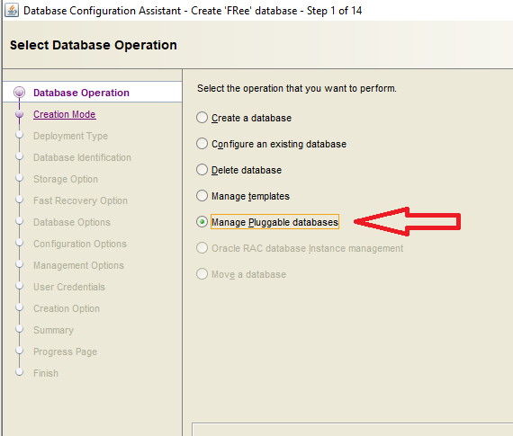
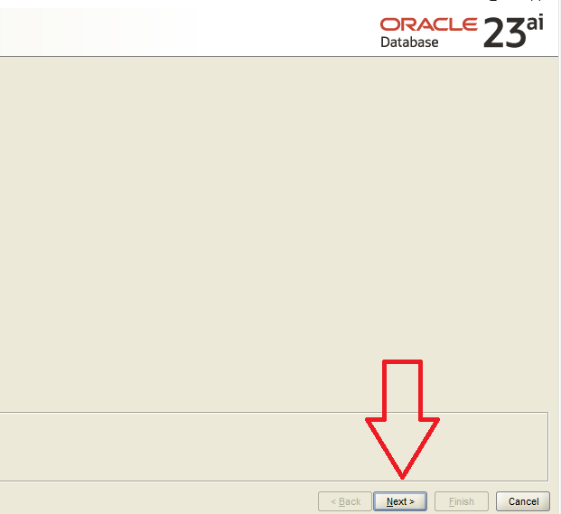

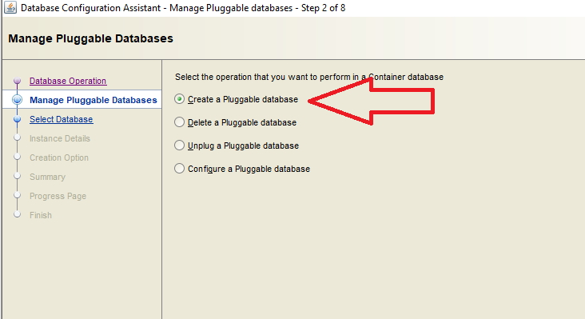

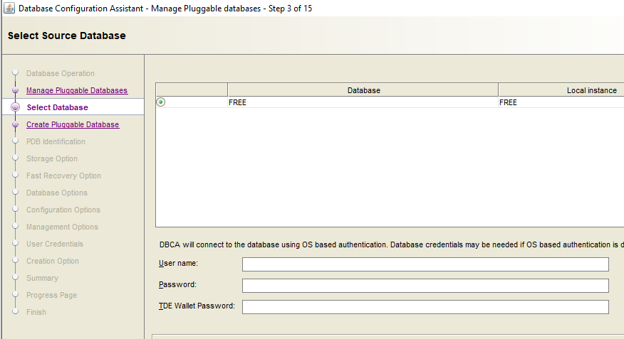

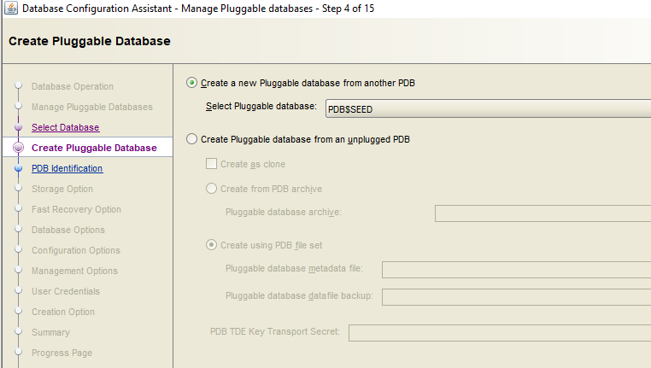

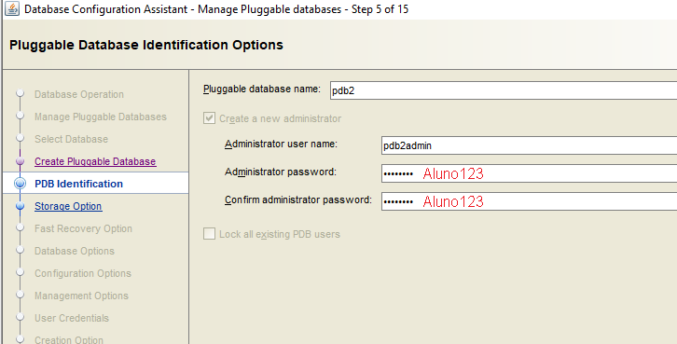

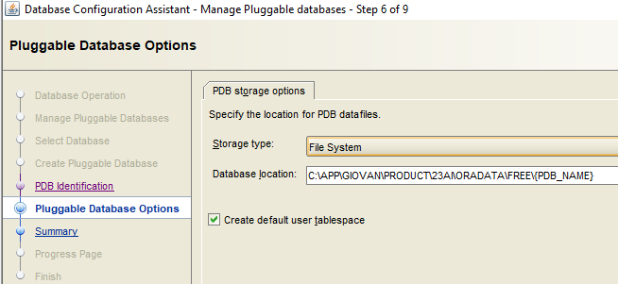

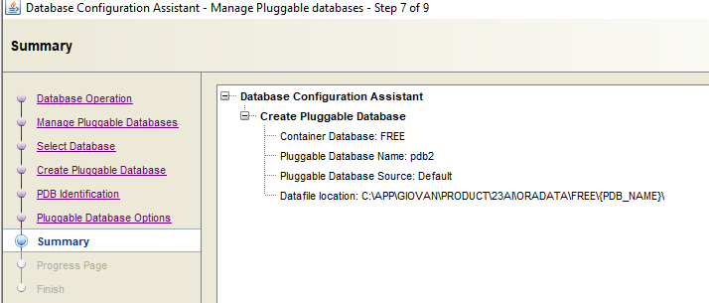
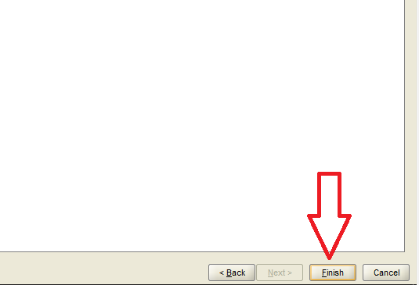

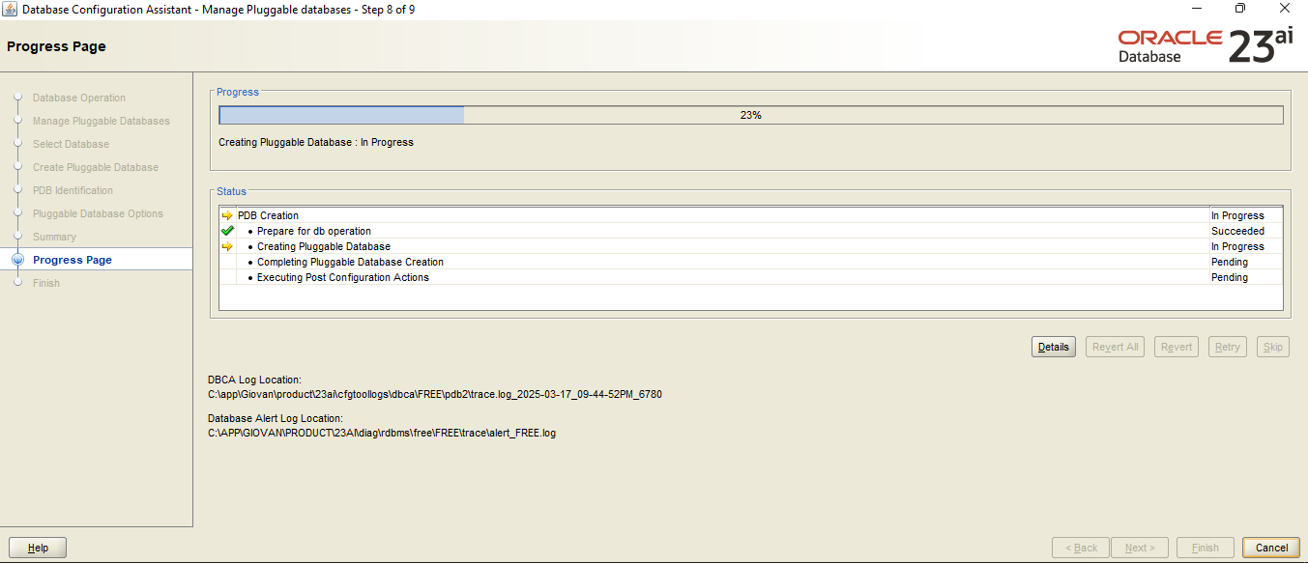

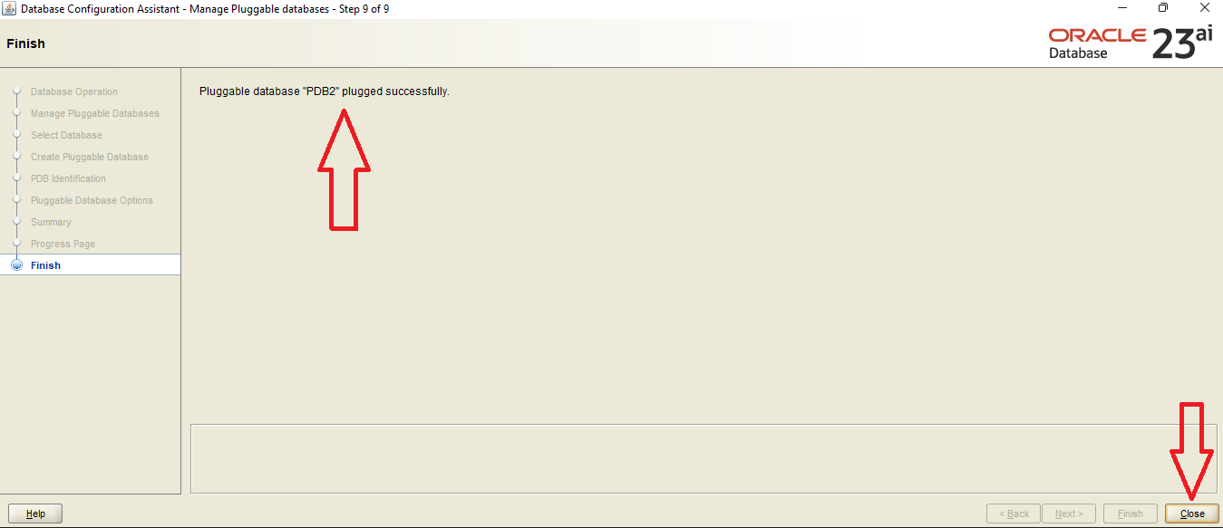

Connect with admin account and privileges
sqlplus / as sysdba

To open:
ALTER PLUGGABLE DATABASE pdb2 OPEN;
exit

Connect
sqlplus system/100@localhost:1521/pdb2

To create a local user:
CREATE USER joe_pdb2 IDENTIFIED BY 100;
GRANT CREATE SESSION, CREATE TABLE, DBA TO joe_pdb2;

CREATE TABLE my_table (
id NUMBER PRIMARY KEY,
name VARCHAR2(100)
);

INSERT INTO my_table (id, name)
VALUES
(1, 'Alice'),
(2, 'Bob');

SELECT * FROM my_table;
exit

To connect in the created database:
sqlplus pdb2admin/Aluno123@localhost:1521/pdb2
SELECT * FROM my_table;

Connect
sqlplus joe_pdb2/100@localhost:1521/pdb2
SELECT * FROM my_table;

Note: the table above was created by system, so pdb2admin and joe_pdb2 get an error trying to execute that SELECT.

Oracle CDB creation
Using SQLPlus* (Manually with SQL commands):
You can create a database with the following steps:
bash
sqlplus sys/oracle as sysdba

Then, in SQL*Plus, run:
sql
SHUTDOWN IMMEDIATE;
STARTUP NOMOUNT;

CREATE DATABASE cdb2
USER SYS IDENTIFIED BY oracle
USER SYSTEM IDENTIFIED BY oracle
LOGFILE GROUP 1 ('/opt/oracle/oradata/FREE/cdb2/redo01.log') SIZE 50M,
GROUP 2 ('/opt/oracle/oradata/FREE/cdb2/redo02.log') SIZE 50M
DATAFILE '/opt/oracle/oradata/FREE/cdb2/system01.dbf' SIZE 700M
AUTOEXTEND ON MAXSIZE UNLIMITED
SYSAUX DATAFILE '/opt/oracle/oradata/FREE/cdb2/sysaux01.dbf' SIZE 500M
AUTOEXTEND ON MAXSIZE UNLIMITED
DEFAULT TEMPORARY TABLESPACE temp
TEMPFILE '/opt/oracle/oradata/FREE/cdb2/temp01.dbf' SIZE 20M
UNDO TABLESPACE undo_tbsp
DATAFILE '/opt/oracle/oradata/FREE/cdb2/undo01.dbf' SIZE 200M;

Instances
SELECT INSTANCE_NAME, STATUS, DATABASE_STATUS FROM V$INSTANCE;
SELECT * FROM V$VERSION;
SHOW INSTANCE;

It is not possible to create another CDB in the Oracle 23 AI free version.

Exercises
Create a pdb called HRDEV. With hradmin/Aluno123
dbca

Open the pdb and verify it status.
sqlplus / as sysdba
ALTER PLUGGABLE DATABASE HRDEV OPEN;
SELECT NAME, OPEN_MODE FROM V$PDBS WHERE NAME = 'HRDEV';
exit

Create a table called HR_EMPLOYEES with EMP_ID, EMP_NAME and DEPT_NAME.
sqlplus system/100@localhost:1521/HRDEV
-- Connect to the HRDEV PDB as hradmin
CONNECT hradmin/Aluno123@HRDEV;
sqlplus hradmin/Aluno123@localhost:1521/HRDEV
CREATE TABLE HR_EMPLOYEES (
EMP_ID NUMBER PRIMARY KEY, -- Unique Employee ID
EMP_NAME VARCHAR2(100), -- Employee Name
DEPT_NAME VARCHAR2(50) -- Department Name
);

Insert some sample data on the table created above.
INSERT INTO HR_EMPLOYEES (EMP_ID, EMP_NAME, DEPT_NAME) VALUES (1, 'Alice', 'HR');
INSERT INTO HR_EMPLOYEES (EMP_ID, EMP_NAME, DEPT_NAME) VALUES (2, 'Bob', 'Finance');
COMMIT;

Create 3 users:
admin_user | Full DBA privileges for database administration.
developer_user | Basic database development privileges (CONNECT, RESOURCE).
joe | Access to specific tables (HR_EMPLOYEES).

CREATE USER admin_user IDENTIFIED BY admin_password;
GRANT DBA TO admin_user;

CREATE USER developer_user IDENTIFIED BY dev_password;
GRANT CONNECT, RESOURCE TO developer_user;

CREATE USER joe IDENTIFIED BY joe_password;
GRANT CONNECT TO joe;
GRANT SELECT ON HR_EMPLOYEES TO joe;
GRANT INSERT, UPDATE, DELETE ON HR_EMPLOYEES TO joe;

Connect to the database using the user joe.
sqlplus joe/joe_password@localhost:1521/HRDEV

Run a select against the database using joe.
SELECT * FROM system.HR_EMPLOYEES;

Creating and managing tables
Oracle Database allows you to store data in structured tables, which are at the heart of any relational database. In this chapter, we’ll explore how to create and manage tables step by step, along with hands-on examples.

Understanding Tables in Oracle
Tables are database objects used to store data in rows and columns. Each table has:
Columns: Define the structure of the data, such as data type (e.g., VARCHAR2, NUMBER).
Rows: Contain the actual data entries.

Creating a Table
To create a table, we use the CREATE TABLE SQL command. Let's walk through the steps.
Connect to the PDB: Log in to your Pluggable Database (e.g., freepdb1) as PDBADMIN or a user with the CREATE TABLE privilege:
sqlplus pdbadmin@freepdb1
Create a Simple Table: Here’s an example of creating a table called employees to store employee details:
CREATE TABLE employees (
emp_id NUMBER PRIMARY KEY,
first_name VARCHAR2(50),
last_name VARCHAR2(50),
email VARCHAR2(100) UNIQUE,
hire_date DATE,
salary NUMBER(10, 2)
);

Inserting Data into the Table
After creating the table, insert some sample data:
INSERT INTO employees (emp_id, first_name, last_name, email, hire_date, salary)
VALUES (1, 'John', 'Doe', 'john.doe@example.com', TO_DATE('2023-03-15', 'YYYY-MM-DD'), 50000);

INSERT INTO employees (emp_id, first_name, last_name, email, hire_date, salary)
VALUES (2, 'Jane', 'Smith', 'jane.smith@example.com', TO_DATE('2022-07-01', 'YYYY-MM-DD'), 60000);

Querying the Table
Retrieve and view data from the table:
SELECT * FROM employees;

Modifying the Table Structure
Adding a Column: To add a new column for department names:
ALTER TABLE employees ADD department VARCHAR2(50);
Renaming a Column: If you need to rename department to dept_name:
ALTER TABLE employees RENAME COLUMN department TO dept_name;
Dropping a Column: To remove a column (e.g., dept_name):
ALTER TABLE employees DROP COLUMN dept_name;

Deleting Data
Delete a Specific Row: Remove an employee with emp_id = 1:
DELETE FROM employees WHERE emp_id = 1;
Delete All Data: Clear all data from the table without removing the table itself:
TRUNCATE TABLE employees;

Dropping a Table
If you want to permanently delete the employees table:
DROP TABLE employees;

Hands-On Practice
Let’s create another table for practice:
CREATE TABLE products (
product_id NUMBER PRIMARY KEY,
product_name VARCHAR2(100),
price NUMBER(10, 2),
stock NUMBER
);

Summary
In this chapter, we covered:
Creating tables with various column types and constraints.
Inserting, querying, and modifying data.
Managing the table structure using ALTER TABLE.
Deleting data or removing tables completely.
Practicing these commands will help you understand the basics of creating and managing tables in Oracle Database.

References
Oracle Database Express Edition (XE) Downloads
https://www.oracle.com/database/technologies/xe-downloads.html
Know more about XE
Oracle Database Express Edition
XE docs
List of Tables
APEX
Develop and Deploy Apps | Oracle APEX Application Development

Links for download
Version 23
A lot of cool things can be founded here:
Database 23ai Free | Oracle
Downloads can be founded here:
Get Started with Oracle Database 23ai | Oracle
How to Create New Pluggable Databases in Oracle 19c

To Do

Create a chapter about Oracle pdb deletion using dbca.
Create a chapter about table creation.
Create a chapter about insert.
Create a chapter about delete.
Create a chapter about update.
Create a chapter about select.

Review the font of the entire e-book.
Review the language of the entire e-book.
Review the references.

